Epsom & Ewell F.C.
14
v
Hanworth Villa F.C.
Tuesday, 13th December 2016 – 7.45 p.m.
Good evening! We welcome the players, supporters and officials of Hanworth Villa, tonight’s officials and of course, our own regular faces! We also welcome back former Salts Tom Neale and Alex McGregor who are likely to appear in opposition colours tonight.

We have already met our opponents once this season when we negotiated a tricky League Cup tie over there in October, requiring extra time to do so. We know that Hanworth Villa are a good team and will present a difficult challenge tonight. However, if we are to finish in the top four or even higher, then these are the type of matches that we have to win.

We also have to overcome the 13th of December. This particular day is statistically the worst in our history with a record of one win, one draw and ten defeats, the latest of which came at Badshot Lea two seasons ago. Our one positive result came in 1980 when we defeated Westfield in the Surrey Senior Cup but it was an important win as we went on to lift the cup that year.

We were last here seven days ago when we hosted our landlords Chipstead in the Surrey Senior Cup; a match that also doubled as the tenth Dave Wilson Trophy, and to say we dominated the match was an understatement as we romped to a 3-0 win that could have been more. Matt Farrell started things off with a penalty after Daryl Cooper-Smith had been fouled by the keeper and second half goals from Agi Panayiotou and Daryl himself made it a very easy passage to the next round by the end. We also had the added bonus of a former Epsom legend Chris Page, who was in goal for our 1975 F.A. Vase Final, presenting the trophy to Dan Dean at the end of the match.

We then visited League leaders Hartley Wintney on Saturday and gave them a good match for the first twenty five minutes, leading through Matt Farrell’s thirteenth goal of the season, but a harsh second yellow card for Matt Tanton changed the game and we were defeated 3-1. Two of their goals were superb free kicks though, so on the day we were more than a little unfortunate. We have to play with the memory of that injustice tonight.

We return here on Saturday to host Chertsey Town with a Christmas fixture at home to Raynes Park Vale on Tuesday 27th December. This particular match will kick off at 11.30 a.m.

We are still in urgent need of both match and player sponsors, so if you can help, please have a word with a Committee Member for details. Thank you!

Finally, the Surrey Senior Cup draw has been made and we are at home to Guildford City or Horley Town in the last 16. This match will be played at some point in the New Year. The full draw will appear in the next programme, although it is already available online.

Enjoy the game!

Rich
You can follow us on Facebook: www.facebook.com/epsomandewellfc Twitter: @EEFCOfficial and
Instagram at: www.instagram.com/epsomandewellfc We also have a Youtube channel now!

Cover photos by Gemma Jarman

- Our starting eleven line up before the recent home match against A.F.C. Hayes

- Daryl Cooper-Smith scores our final goal in the 6-3 win at Worcester Park

Cherry Red Records Combined Counties League
Premier Division Table 2016/17
incl Saturday 10th December | P | W | D | L | F | A | Pts | GD | H | A
Hartley Wintney | 24 | 20 | 2 | 2 | 79 | 23 | 62 | +56 | 18/3 | 1-3
Westfield | 22 | 15 | 5 | 2 | 51 | 21 | 50 | +30 | 18/2 | 1-2
Hanworth Villa | 24 | 14 | 3 | 7 | 38 | 28 | 45 | +10 | 13/12 | 14/1
Walton & Hersham | 20 | 12 | 6 | 2 | 35 | 17 | 42 | +18 | 4/3 | 1-1
Knaphill | 22 | 12 | 2 | 8 | 47 | 40 | 38 | +7 | 4-0 | 8/4
Guildford City | 26 | 11 | 5 | 10 | 55 | 52 | 38 | +3 | 17/1 | 2-0
Horley Town | 21 | 10 | 5 | 6 | 43 | 30 | 35 | +13 | 3-0 | 17/4
Windsor | 25 | 10 | 5 | 10 | 45 | 43 | 35 | +2 | 2-0 | 1-2
Epsom & Ewell | 20 | 10 | 4 | 6 | 49 | 30 | 34 | +19 | X | X
Colliers Wood United | 23 | 9 | 6 | 8 | 40 | 38 | 33 | +2 | 14/4 | 0-5
Bedfont Sports | 19 | 9 | 4 | 6 | 38 | 38 | 31 | 0 | 5-1 | 7/2
Spelthorne Sports | 22 | 8 | 5 | 9 | 37 | 35 | 29 | +2 | 7/1 | 25/2
Camberley Town | 21 | 8 | 4 | 9 | 38 | 28 | 28 | +10 | 0-0 | 1/4
North Greenford United | 21 | 8 | 4 | 9 | 45 | 43 | 28 | +2 | 22/4 | 1-2
CB Hounslow United | 20 | 8 | 2 | 10 | 34 | 43 | 26 | -9 | 1-5 | 12/11
Abbey Rangers | 22 | 7 | 4 | 11 | 31 | 42 | 25 | -11 | 7-1 | 20/2
Farnham Town | 21 | 7 | 2 | 12 | 33 | 45 | 23 | -12 | 25/3 | 2-1
Sutton Common Rovers | 19 | 6 | 3 | 10 | 26 | 35 | 21 | -9 | 2-1 | 2/1
AFC Hayes | 22 | 5 | 5 | 12 | 33 | 47 | 20 | -14 | 2-2 | 28/1
Chertsey Town | 22 | 5 | 5 | 12 | 25 | 54 | 20 | -29 | 17/12 | 11/2
Raynes Park Vale | 23 | 4 | 5 | 14 | 30 | 50 | 17 | -20 | 27/12 | 1-1
Badshot Lea | 23 | 5 | 2 | 16 | 30 | 63 | 17 | -33 | 4/2 | 4-1
Bedfont & Feltham | 22 | 3 | 4 | 15 | 26 | 63 | 13 | -37 | 21/1 | 9-2

Lucky Day? – 13th December
Played 12 - Won 1 Drawn 1 Lost 10 - For 13 Against 34 - PPG 0.33 - Awful!
Our Club record against Hanworth Villa
Played 15 - Won 8 Drawn 3 Lost 4 - For 38 Against 26 - PPG 1.80 - Good
Our Largest wins and losses against our opponent
21st November 2015 - W 5-0 - Combined Counties League (H)
26th April 2014 - L 1-4 - Combined Counties League (H)
Their Last Visit
21st November 2015 - W 5-0 - Combined Counties League

First Eleven Appearances 2016/17 - (max 28)
Name | Debut | 2016/17 |  |  |  | Career Totals
 |  | App | Sub | Total | Goals | App | Sub | Total | Goals
CLARK-GLEAVE Charlie | 23/08/2016 | 2 | 2 | 4 | 0 | 2 | 2 | 4 | 0
COOPER-SMITH Daryl | 03/01/2015 | 21 | 1 | 22 | 25 | 51 | 9 | 60 | 45
DEAN Dan | 02/08/2014 | 19 | 2 | 21 | 0 | 87 | 6 | 93 | 2
DEWAR Ali | 29/10/2011 | 0 | 1 | 1 | 0 | 55 | 36 | 91 | 10
EACOTT Michael | 02/08/2014 | 22 | 0 | 22 | 0 | 107 | 1 | 108 | 0
FARRELL Matt | 02/08/2014 | 26 | 0 | 26 | 13 | 112 | 4 | 116 | 31
FERDINANDO Matt | 20/09/2014 | 14 | 4 | 18 | 2 | 67 | 10 | 77 | 16
GALLAGHER Jordan | 07/08/2016 | 14 | 12 | 26 | 6 | 14 | 12 | 26 | 6
GRIFFIN Reisse | 08/08/2015 | 20 | 4 | 24 | 2 | 48 | 10 | 58 | 4
HASTINGS Craig | 08/08/2015 | 18 | 5 | 23 | 1 | 55 | 9 | 64 | 1
HEAGNEY Adam | 16/08/2016 | 17 | 3 | 20 | 0 | 17 | 3 | 20 | 0
HENDRY Rob | 08/08/2015 | 18 | 7 | 25 | 3 | 48 | 18 | 66 | 15
MCKAY Alex | 20/12/2008 | 16 | 3 | 19 | 3 | 124 | 33 | 157 | 11
NEALE Tom* | 13/10/2015 | 6 | 5 | 11 | 7 | 22 | 24 | 46 | 17
NORTH Rhys* | 16/08/2015 | 2 | 2 | 4 | 0 | 19 | 9 | 28 | 1
NWACHUKWU Jason | 01/10/2016 | 4 | 6 | 10 | 0 | 4 | 6 | 10 | 0
PANAYIOTOU Savvas | 03/01/2015 | 22 | 3 | 25 | 4 | 54 | 11 | 65 | 11
PRICE Matt* | 23/08/2016 | 2 | 0 | 2 | 1 | 2 | 0 | 2 | 1
ROBINSON Sam* | 22/10/2011 | 7 | 1 | 8 | 1 | 61 | 6 | 67 | 14
ROSE Daniel | 25/10/2016 | 2 | 4 | 6 | 0 | 2 | 4 | 6 | 0
SALEH Mennar* | 24/09/2016 | 0 | 2 | 2 | 0 | 0 | 2 | 2 | 0
SMITH Matt | 08/08/2009 | 0 | 2 | 2 | 1 | 91 | 45 | 136 | 11
TANTON Matt | 02/08/2014 | 24 | 1 | 25 | 1 | 81 | 5 | 86 | 3
TAYLOR James | 26/08/2013 | 22 | 3 | 25 | 1 | 108 | 15 | 123 | 7
THOMPSON Elliott | 09/02/2016 | 3 | 0 | 3 | 1 | 7 | 9 | 16 | 1
TURPIE Alistair | 31/03/2016 | 6 | 1 | 7 | 0 | 8 | 1 | 9 | 0
WATRET Jack* | 02/08/2016 | 1 | 0 | 1 | 0 | 1 | 0 | 1 | 0
* player has left the club

Latest Results and Fixtures
Surrey Senior Cup Second Round – Tuesday 6th December
Epsom & Ewell | 3-0 | Chipstead
Raynes Park Vale | 1-1 | Sutton United
Raynes Park Vale won 4-3 on penalties
Whyteleafe | Abandoned | Colliers Wood United
Combined Counties League – Tuesday 6th December
CB Hounslow United | 1-2 | Chertsey Town
Farnham Town | 2-3 | Guildford City
Hanworth Villa | 1-0 | Abbey Rangers
Horley Town | 0-0 | Walton & Hersham
Buildbase F.A. Vase Third Round Replay – Wednesday 7th December
Bedfont Sports | 2-3 | Crowborough Athletic
Combined Counties League – Saturday 10th December
AFC Hayes | 2-5 | Walton & Hersham
Badshot Lea | 2-1 | Horley Town
Bedfont & Feltham | 0-3 | North Greenford United
Bedfont Sports | 1-1 | Colliers Wood United
Chertsey Town | 0-1 | Knaphill
Guildford City | 0-1 | Sutton Common Rovers
Hanworth Villa | 1-0 | Farnham Town
Hartley Wintney | 3-1 | Epsom & Ewell
Spelthorne Sports | 4-0 | CB Hounslow United
Westfield | 2-1 | Camberley Town
Windsor | 4-2 | Abbey Rangers
Combined Counties League – Monday 12th December
Sutton Common Rovers | V | Abbey Rangers
Surrey Senior Cup Second Round – Tuesday 13th December
Badshot Lea | V | Farnham Town
Combined Counties League – Tuesday 13th December
Bedfont & Feltham | V | Chertsey Town
Camberley Town | V | CB Hounslow United
Epsom & Ewell | V | Hanworth Villa
Horley Town | V | Knaphill
Walton & Hersham | V | Bedfont Sports
Latest Results and Fixtures
Surrey Senior Cup Second Round – Wednesday 14th December
Guildford City | V | Horley Town
Combined Counties League – Saturday 17th December
AFC Hayes | V | Guildford City
Abbey Rangers | V | Walton & Hersham
Camberley Town | V | Bedfont & Feltham
CB Hounslow United | V | Bedfont Sports
Epsom & Ewell | V | Chertsey Town
Farnham Town | V | Colliers Wood United
Horley Town | V | Windsor
Knaphill | V | Hartley Wintney
North Greenford United | V | Westfield
Raynes Park Vale | V | Sutton Common Rovers
Spelthorne Sports | V | Hanworth Villa
Combined Counties League Cup Third Round – Monday 19th December
Sutton Common Rovers | V | Walton & Hersham
Combined Counties League – Tuesday 27th December (11.30am k.o.)
Abbey Rangers | V | Spelthorne Sports
Bedfont & Feltham | V | CB Hounslow United
Bedfont Sports | V | North Greenford United
Camberley Town | V | Farnham Town
Chertsey Town | V | Horley Town
Epsom & Ewell | V | Raynes Park Vale
Hanworth Villa | V | AFC Hayes
Hartley Wintney | V | Badshot Lea
Walton & Hersham | V | Westfield
Windsor | V | Knaphill
Combined Counties League – Wednesday 28th December
Colliers Wood United | V | Sutton Common Rovers
Quick stat
If we are able to score one more goal in either this match or the one against Chertsey Town on Saturday we will have reached the 50 League goal mark before Christmas for only the second time in history. The previous time we did it was last year when co-incidentally we also had 49 goals after 20 matches!

From behind the goal
Epsom & Ewell 3-0 Chipstead
Surrey Senior Cup - Second Round - Tuesday 6th December 2016

Local honours go to the tenants

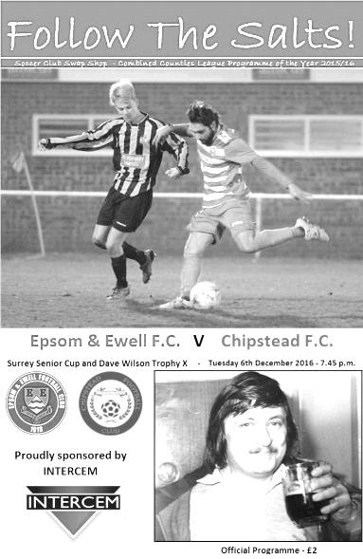
On Tuesday we won our second consecutive cup match by three clear goals, following the win at Worcester Park three days previously. However, this time our opponents were Step Four Chipstead in the Surrey Senior Cup and by the end of the match we had finished as worthy winners with the added bonus of retaining the Dave Wilson Trophy for the third consecutive season.

The opportunity was taken to double this match with our Memorial Trophy following a cancellation of the originally scheduled pre-season friendly. Whether this gave any added motivation to our players ahead of the opposition is impossible to say, but we clearly appeared more up for the battle than our landlords who, like ourselves, have more important League fixtures coming up.

In terms of personnel, the main news was the recall of Charlie Clark-Gleave into the starting eleven following a period out of the side and Dan Dean returned from suspension to give Alex McKay a rest. Such was the strength of our bench last night that McKay did not even have a place in the 16! Matt Farrell also came back from suspension in place of Daniel Rose and Michael Eacott returned between the posts for Ali Turpie.

The competition for places is currently as strong as I have ever seen it at this club and to see a bench containing Rose, Craig Hastings, Matt Ferdinando, Jason Nwachukwu and Ali Dewar gives massive hope for the remainder of the season, and we played like a confident team, going at our "visitors" from the start. We had three opportunities in the opening five minutes as a free kick was sliced over his own bar by Matt Warren and then a wicked corner from Rob Hendry went straight through everyone just a couple of yards out from the goal line. Even Captain Dean got in on the act in his midfield role, seeing his low 25 yard strike deflected for another corner. In response Chipstead had a long shot of their own but a deflection took the pace off the ball a little and Eacott was able to make a comfortable save.

We went ahead in the 15th minute and it was a strange goal for Chipstead to concede as the opportunity came from their own free kick, which was cleared straight to Daryl Cooper-Smith in acres of space about thirty yards out. As he reached the goal he rounded the keeper but was brought down for the penalty with Giordan Zabotti being fortunate that the rules had changed this season as he quite rightly received a yellow card, where last year he would have been walking off for being the last man. Matt Farrell stepped up and confidently dispatched the penalty to give us the early lead.

We continued to press and a succession of corners followed. Zabotti just got his hand to a dangerous Jordan Gallagher delivery ahead of the incoming Dean, before a Hendry corner was met by a defender who sliced the ball down into the ground and it bounced up, clearing the crossbar by inches. Zabotti then mistimed a punch for the next delivery and watched the ball clear his own bar before Farrell's strike from the next set piece was saved to end the pressure.

Our landlords came back into the match for a spell, causing difficulty on the right wing with a low cross that was stopped in the six yard box by a defender allowing the grateful Eacott to fall on the ball. Moments later a high ball was miscontrolled by Adam Heagney and it put their striker straight through but his shot was wide from close range.

We turned defence into attack and Agi Panayiotou, clearly enjoying his more advanced role, twisted and turned before curling a shot to the far post but Zabotti saved it and was there again minutes later after Cooper-Smith had set him up for a low shot from the edge of the area. As we went off for half time I felt that we probably deserved to be further ahead than we were and of course you always wonder whether it would come back to haunt us in the second half.

Not tonight though as we carried on pressing the opposition and Hendry had the first opportunity but coming in from the right he dragged his low shot just wide of the near post. In response, Eacott made a good low save from a strike on the left but the opposition attacks were becoming fewer. We had a moment of concern soon after but this was as a result of Matt Tanton colliding heavily with an advertising hoarding. Fortunately he was able to go again after a bit of recovery time.

Eacott made a good save from a free kick on the edge of the area but the remaining half an hour was all Epsom and we extended our lead in the 67th minute after Panayiotou won the ball and ran with it at goal before setting up Cooper-Smith in space on the left but after dragging players over he then unselfishly squared the ball where both Farrell and Panayiotou were waiting with the latter tucking the ball past Zabotti from 8 yards out.

A third goal followed ten minutes later when Cooper-Smith found more space out on the left and he drove the ball low at goal from around 12 yards but it swerved late and embarrassed the keeper as it went through him completely to register his 25th goal of the season.

Both Rose and Ferdinando came on in the final twenty minutes and both showed plenty of application with Rose having a bit of space on the edge of the box but his attempt was sliced just wide and the match closed with further attacks with James Taylor being just wide with two attempts from two corners in the space of two minutes!

Overall though it was a fantastic performance and in addition to the Surrey Senior Cup progress, Dean was presented after the game with the Dave Wilson Trophy by Epsom goalkeeping legend and member of the 1975 Wembley Vase Final squad Chris Page. All in all it was a great evening for the official home side!

Epsom and Ewell: Michael Eacott, Adam Heagney, Matt Tanton, James Taylor,
Charlie Clark-Gleave, Dan Dean (c), Rob Hendry, Matt Farrell, Daryl Cooper-Smith,
Savvas 'Agi' Panayiotou, Jordan Gallagher
Subs: Daniel Rose for Dean (72), Matt Ferdinando for Hendry (80)

From behind the goal
Hartley Wintney 3-1 Epsom & Ewell
Combined Counties League - Premier Division - Saturday 10th December 2016

Ten man Salts unable to hold on against leaders

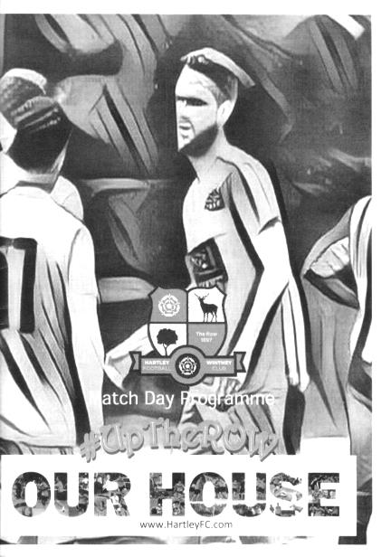
Following two entertaining and conclusive cup tie wins in the last seven days we went into this league match at table topping Hartley Wintney with confidence high. A decent crowd were present at a very wet Green Lane to see how the encounter would develop. Regrettably though we were all deprived of the opportunity to see an even contest by an early sending off and fell to defeat after threatening to defeat the current Champions on their own patch.

In terms of personnel we were missing our leading scorer Daryl Cooper-Smith through suspension, although the hosts were also missing one of their two excellent strikers Ross Cook, so neither side could complain of any disadvantage in that area. For us Rob Hendry took our leading scorer's position and put in a great shift, especially in the second half when his service became more limited. Additionally Craig Hastings returned to the starting eleven at the expense of Charlie Clark-Gleave while Matt Ferdinando came back in for the aforementioned Cooper-Smith.

And I thought Ferdinando's afternoon was going to last for precisely 11 seconds as he had a clash of heads with their left back almost immediately after the game had started, although fortunately both players were able to continue after treatment.

The opening encounters were even. The home side were playing some dangerous balls into our area while we were getting some success down the left flank. The first shot on goal came from Hendry who took aim from the edge of the area after a good turn but Paul Strudley was able to make the comfortable save. However, he could do nothing about our goal which also came from the left in the 15th minute. Jordan Gallagher, fresh from providing a number of assists in recent matches, made space on the wing to drill a low cross to the penalty spot where Matt Farrell was waiting to strike. As it turned out, his left footed contact wasn't the greatest and Strudley would surely have saved it had it not deflected past him off defender Steve Noakes.

the home side responded as we knew they would and a nice passing move resulted in a low strike which Michael Eacott kept out with his right foot. A minute later Matt Tanton picked up a yellow card for kicking the ball away after a free kick had been awarded against him, before Eacott made a full stretch save of a strike from the edge of the area as Hartley began to push us back. The home team kept up the pressure though and as one of their players looked to shoot, Tanton went to block the shot only to see the player then fall over his leg about 25 yards from goal. After deliberation and consultation the referee surprisingly decided the challenge warranted a second yellow card and Tanton was off just 26 minutes into the match. Instantly thoughts went back to

another recent important match in the F.A. Vase when Reisse Griffin had picked up an early card and regrettably this match would end up the same way. Any thoughts of holding on to our one goal lead were dispelled moments later by a peach of a strike into the top corner from the free kick by Steve Duff.

As the half concluded Gallagher found himself in an more defensive position on the field but made an excellent covering tackle just as a striker was about to pull the trigger and this ensured that the teams were still level at the break, although Hendry was unlucky not to break the deadlock after a Ferdinando free kick was inadvertently flicked on by a defender and his volley from ten yards out thudded against Strudley's left hand post and away with seconds remaining in the half.

Unfortunately, despite going down the slight hill in the second half we were unable to maintain the performance level. We started in the worst possible way by conceding within three minutes of the restart. Dan Dean picked up a yellow card for sliding in dangerously in the referee's opinion, and Duff scored his second great free kick goal with a curling effort from nearly thirty yards that left Eacott flat footed. It looked like the ball had gone over the bar from where I was and the crowd's reaction when the goal went in told me that they might have been thinking the same! Disappointingly, I'm not sure that I have ever seen two free kicks as good as that in the one match before.

We had been dealing with the home side's barrage of long throws fairly well throughout the first half but the first one of the second half in the 58th minute was only half cleared and when the ball was crossed back in, Sam Argent was there to guide his header into the top corner to extend the lead to 3-1.

It was a long way back from here, although we had recovered from 3-1 down after an hour to draw on our last visit. Ferdinando arrived at the far post to rifle a low shot at goal from ten yards but it was kept out well by Strudley and as the match reached its final stages it was the home side that had the greater opportunities to score again but they were denied by some fine saves from Eacott. Ultimately we just ran out of steam against a good team.

It is of course impossible to say whether we would have held on to or even extended our lead had we kept all eleven men on the field and I am also aware that some of our players feel a bit hard done by at present and with some justification, but we urgently need to find a way of reducing the number of suspensions we keep picking up, while at the same time remaining physical and competitive on the pitch. The only way to do this would be to cut down on the avoidable situations like kicking the ball away, dissent and the general conduct on the pitch which will not endear ourselves to a referee about to make a borderline decision. Last season we finished ten points behind promoted Ashford Town, yet had 11 players sent off, which surely cost us a number of points. With the tally at four red cards already this season we can no longer solely blame the officiating for this, even though it was horribly erratic at times in this match. We have to look at ourselves too.

With exception of Tanton who will now serve a one match suspension, all the other suspensions have now cleared, so the best way to get over this match is to take it out on third placed Hanworth Villa at Chipstead on Tuesday by letting our football do the talking. If we can't, then our hopes of a top four finish reduce significantly.

Epsom and Ewell: Michael Eacott, Adam Heagney, Matt Tanton, James Taylor, Craig Hastings, Dan Dean (c), Jordan Gallagher, Matt Farrell, Rob Hendry, Savvas 'Agi' Panayiotou

Subs: Jason Nwachukwu for Dean (67), Daniel Rose for Ferdinando (79)

Hanworth Villa F.C. – History
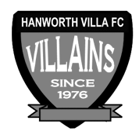
Hanworth Villa were formed in 1976 following a managerial disagreement at another long established Hanworth club. In the early years the team struggled in Division One of the Hounslow & District League, scoring a goal was usually celebrated with a public holiday. During the close season and following hard work by Jimmy Connors, who rebuilt the team, they finished Division One Champions.

The following season saw the club start an incredible run in the league, which finished 68 matches later, with 'The Villains' winning the Hounslow Premier League, and the West Middlesex Division One and Two Championships. The success continued with Hanworth being elected to the newly formed Middlesex County Football League.

From 1980 the club had a nomadic existence but in 1997 moved to its existing Headquarters at Rectory Meadow. This move led to the formation of Hanworth Villa Sunday, and later a reserve team, being an amalgamation of teams from - The Sawyers Arms, The Queen Dowager, and Feltham Railway Club, not that the lads like the odd beer! A Chiswick League double in 1993 and a 19-0 Cup Final victory in the National Railways Cup (did the opposition run out of steam?) cemented the successful amalgamation.

Following hard work by Dave Brown the club was granted a lease at Rectory Meadow. At last we had a permanent home and could set about converting an existing pavilion into a clubhouse, which has become known locally as “The Ranch”. With a permanent base we were able to concentrate on improving our football, and recent years have seen all our teams win numerous trophies, the most notable performance being by our Sat 1st team who landed “the treble” in 02/03, winning the Middlesex County Premier league, the Open Cup and the League Cup. After another premier league title in 2004/05, this time with a record number of points, it was decided that it was time to move on and the club were elected to Division One of the Combined Counties League in time for the start of the 05/06 campaign.

The Combined Counties Experience
It took a while to adapt to the new level of football, but in our second season we managed to win the Challenge cup. The following season, 2007/08, we successfully managed to defend the Challenge Cup and narrowly missed out on the league title, finishing a creditable second; our facilities however, prevented our promotion into the Premier Division. The club were determined to ensure that that situation wouldn’t arise again, and, with typical determination, the committee managed to raise the funds to ensure that floodlights and a spectator stand were installed in time for the start of the 08/09 campaign. The effort wasn’t in vain as we once again finished second in what was a very tight end to the season with the top 5 sides being separated by just 3 points. After a successful ground inspection we were promoted to the CCFL Premier in time for the 2009/10 season.

Our debut season in the Premier proved to be as difficult as we expected. Points were few and far between for the first half of the season, but we gradually started to come to terms with the improvement in standard required, and we managed to put together performances worthy of a CCFL Premier side. By the end of the season we had obtained enough points to finish in 17th position, 3 clear of the relegation places.

That 1st season taught us a lot and changes put in place during the close season allowed us to have a more comfortable second season, in which, we not only finished a creditable 5th in the league, but also reached the finals of the Middlesex Senior Charity Cup and also, for the 2nd consecutive season, the Southern Combination Cup. Unfortunately we lost out by the odd goal in both finals.

2012/13 saw us finish 3rd in the CC FL our highest ever position in the football pyramid since we were formed in 1976. There was also a very creditable run in both the FA Cup and Vas competitions. In the FA Cup we just lost out to AFC Totton 3-2 missing our on a first round proper tie with Bradford Park Avenue. Our run in the FA Cup saw wins over Shrivenham, Bedfont Sports, Wembley, Aveley and Slough Town. In the FA Vase we lost out to Herne Bay one of the beaten semi-finalists at the third round stage.

The 2013/14 season contained a top ten finish and another good F.A. Vase run although last season was a battle throughout, only surviving at the end after a good end of season run. Now under the charge of former professional player Rufus Brevett, the club hopes for better things.

Combined Counties League Premier Division Opponents
All-time Records
incl Saturday 10th  December | P | W | D | L | F | A | PPG | GD | Best  Win | Worst  Loss
Bedfont & Feltham | 1 | 1 | 0 | 0 | 9 | 2 | 3.00 | +7 | 9-2 | X
Spelthorne Sports* | 5 | 4 | 1 | 0 | 15 | 6 | 2.60 | +9 | 6-2 | X
Sutton Common Rovers | 11 | 9 | 1 | 1 | 29 | 13 | 2.55 | +16 | 4-0 | 1-4
Horley Town | 29 | 20 | 5 | 4 | 65 | 30 | 2.24 | +35 | 6-0 | 1-3
Colliers Wood United | 22 | 14 | 2 | 6 | 45 | 33 | 2.00 | +12 | 4-0 | 0-5
Bedfont Sports | 10 | 6 | 2 | 2 | 18 | 11 | 2.00 | +7 | 5-1 | 0-4
Abbey Rangers | 3 | 2 | 0 | 1 | 10 | 4 | 2.00 | +6 | 7-1 | 2-3
Westfield | 19 | 11 | 3 | 5 | 40 | 31 | 1.89 | +9 | 6-1 | 0-4
Farnham Town | 14 | 8 | 2 | 4 | 25 | 23 | 1.86 | +2 | 3-1 | 1-4
Knaphill | 7 | 4 | 1 | 2 | 15 | 8 | 1.86 | +7 | 4-0 | 1-2
Guildford City | 17 | 10 | 1 | 6 | 34 | 22 | 1.82 | +12 | 5-1 | 1-5
Hanworth Villa | 15 | 8 | 3 | 4 | 38 | 26 | 1.80 | +12 | 5-0 | 1-4
Raynes Park Vale | 27 | 13 | 6 | 8 | 58 | 37 | 1.67 | +21 | 6-1 | 0-2
Badshot Lea | 18 | 8 | 3 | 7 | 35 | 34 | 1.67 | +1 | 4-1 | 0-4
Walton & Hersham | 50 | 24 | 10 | 16 | 101 | 97 | 1.64 | +4 | 6-0 | 0-8
Camberley Town* | 89 | 38 | 22 | 28 | 158 | 123 | 1.52 | +35 | 9-1 | 0-4
Hartley Wintney | 11 | 4 | 3 | 4 | 26 | 20 | 1.36 | +6 | 5-0 | 2-4
Windsor | 49 | 19 | 12 | 18 | 90 | 90 | 1.41 | 0 | 4-0 | 0-6
Chertsey Town | 47 | 17 | 5 | 25 | 70 | 86 | 1.19 | -16 | 3-0 | 0-7
AFC Hayes | 9 | 2 | 3 | 4 | 18 | 17 | 1.00 | +1 | 7-0 | 0-3
North Greenford United | 11 | 3 | 2 | 6 | 15 | 20 | 1.00 | -5 | 3-0 | 1-4
CB Hounslow United | 2 | 0 | 0 | 2 | 2 | 7 | 0.00 | -5 | X | 1-5
* includes one abandoned match v Camberley and one loss on penalties v Spelthorne

Club Records - 13th December
Date | Day | Competition |  | Opponents |  | Scorers
13/12/24 | Sat | Surrey Senior League | A | Godalming | 0-0
13/12/30 | Sat | Amateur Cup 1 | H | Ilford | 2-5 | R.Marlow, T.Jones
13/12/47 | Sat | London League | H | Bedford Town Reserves | 1-3 | B.Peacock
13/12/52 | Sat | Corinthian Memorial Shield 2 | A | Uxbridge | 1-2 | V.Honey
13/12/58 | Sat | Surrey Senior Cup 1 | A | Dorking | 1-5 | R.Brunwin
13/12/69 | Sat | Athenian League 2 | A | Herne Bay | 2-3 | K.Gregory (2)
13/12/75 | Sat | Athenian League 2 | A | Molesey | 0-1
13/12/80 | Sat | Surrey Senior Cup 4q | H | Westfield | 2-1 | T.Tuite, o.g.
13/12/86 | Sat | Isthmian League 1 | A | Tilbury | 0-1
13/12/97 | Sat | Isthmian League 3 | H | Ware | 1-2 | A.Boxall
13/12/03 | Sat | Isthmian League 1s | A | Slough Town | 1-7 | A.Broomhead
13/12/14 | Sat | Combined Counties  Premier Division | A | Badshot Lea | 2-4 | K.Hough (2 pens)
Historical Decades
Date | Day | Competition |  | Opponents |  | Scorers
90 years ago – Epsom Town F.C.
11/12/26 | Sat | Friendly | H | Leyland Motors | 7-1 | R.Marlow (4), W.Challis, J.Parr, H.Westlake (pen)
80 years ago – Epsom F.C.
12/12/36 | Sat | London League | A | Streatham Town | 1-1 | T.Rochester
70 years ago – Epsom F.C.
14/12/46 | Sat | London League | A | Eton Manor | 0-5
60 years ago – Epsom F.C.
15/12/56 | Sat | Surrey Senior Cup 1 | H | Kingstonian | 5-1 | B.Jenkins, J.Sorensen, D.Hermitage, J.Bangs, T.Day
50 years ago – Epsom & Ewell F.C.
17/12/66 | Sat | Athenian League 2 | A | Wingate | 7-5 | A.Cox (2), T.Williams (2), T.Williamson, C.Spriggs, o.g.
40 years ago – Epsom & Ewell F.C.
11/12/76 | Sat | Surrey Senior Cup 4q | A | Redhill | 5-0 | T.Tuite (2), K.Eshelby, A.Webb, A.Reid
30 years ago – Epsom & Ewell F.C.
13/12/86 | Sat | Isthmian League 1 | A | Tilbury | 0-1
20 years ago – Epsom & Ewell F.C.
14/12/96 | Sat | Isthmian League 3 | A | East Thurrock United | 2-3 | A.Boxall (2, 1 pen)
10 years ago – Epsom & Ewell F.C.
12/12/06 | Tue | Surrey Senior Cup 2 | H | Chertsey Town | 2-3 | D.Marvell, S.Hatton

History Corner – 13th December
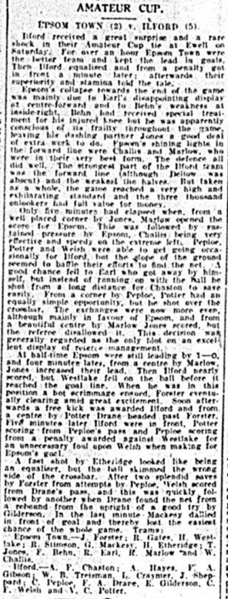
There’s no getting away from it, the 13th December is the worst day in our playing history!

86 years ago today we reached the First Round Proper of the Amateur Cup, following wins over West Norwood, Carshalton Athletic, Mitcham Wanderers and Whyteleafe Albion but luck was not on our side as we pulled out the holders Ilford in the last 64 of the competition at West Street.

Despite this, we led at half time and even extended this to 2-0 shortly after the start of the second half, but the Isthmian League giants showed their class to fight back quickly with three goals and scored twice more near the end as we tired.

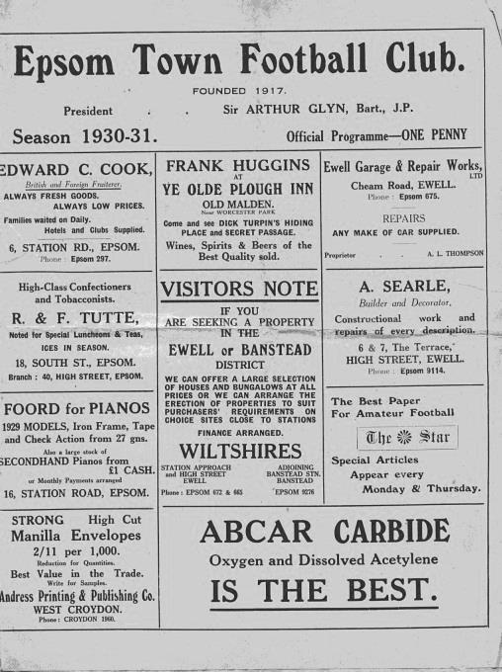
50 years ago this week we had just been suspended by the Surrey F.A. due to our disciplinary record!

Fortunately our Chairman George Tarran led an appeal and the suspension was lifted. We celebrated this the next day at Wingate’s long lost Hall Lane ground with a bizarre 7-5 League win that didn’t contain a single foul in it, said the reports, which described the match as like nuns against vicars, so well behaved were the teams!

Centre page for results

Centre page for results

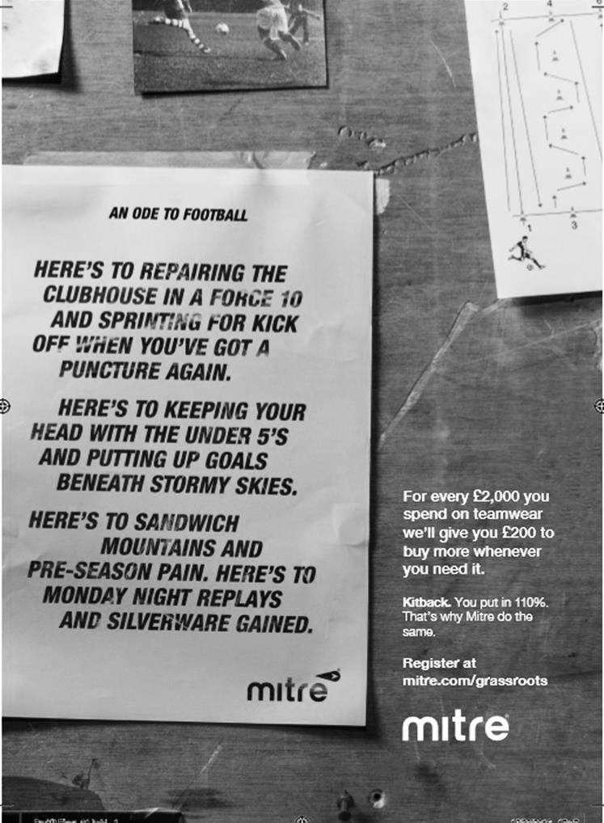

Buildbase F.A. Vase
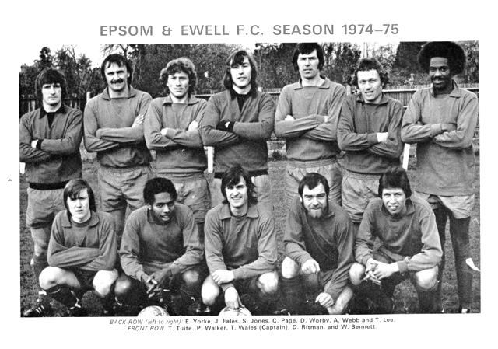

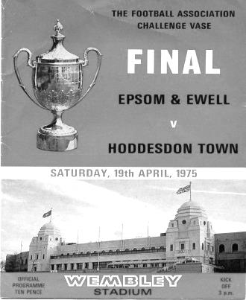
Third Round – 32 ties (Combined Counties League clubs shaded)
North Shields | 1-2 | Shildon
Newton Aycliffe | 2-3 | Morpeth Town
Cleethorpes Town | 2-1 | Bootle
South Shields | 3-0 | Staveley MW
Penrith AFC | 0-3 | Atherton Collieries
Dunston UTS | 1-3 | Sunderland RCA
Bottesford Town | 1-2 | Billingham Town
Hucknall Town AFC | 1-2 | AFC Mansfield
Nuneaton Griff | 0-2 | Bromsgrove Sporting
Sporting Khalsa | 5-5+ r3-0 | Sleaford Town
Coleshill Town | 4-1 | Westfields
Hinckley AFC | 2-1+ | Quorn
Long Eaton United | 2-4+ | Shepshed Dynamo
Wembley | 0-4 | Peterborough Sports
FC Romania | 1-1+ r1-2 | Tring Athletic
Newport Pagnell Town | 3-1 | London Colney
Gorleston | w/o Gorleston | Basildon United
St Margaretsbury | 1-3 | Berkhamsted
Sun Sports | 3-1 | Hoddesdon Town
Welwyn Garden City | 2-3 | Ely City
Abbey Rangers | 1-2 | Eastbourne Town
Crowborough Athletic | 2-2+ r3-2 | Bedfont Sports
Croydon | 3-2 | Glebe
Knaphill | 1-2 | Southall
Newhaven | 1-3 | Chichester
Sutton Common Rovers | 1-4 | Corinthian
Horsham YMCA | 0-3 | Buckland Athletic
Bemerton Heath Harlequins | 2-3 | Melksham Town
Team Solent | 1-0 | Bodmin Town
Bradford Town | 2-0 | Torpoint Athletic
Bristol Manor Farm | 4-1 | Thatcham Town
Exmouth Town | 5-0 | Blackfield & Langley
Fourth Round – 7th January
Shildon | V | Atherton Collieries
Billingham Town | V | Cleethorpes Town
AFC Mansfield | V | Sunderland RCA
South Shields | V | Morpeth Town
Gorleston | V | Coleshill Town
Sun Sports | V | Bromsgrove Sporting
Newport Pagnell Town | V | Peterborough Sports
Sporting Khalsa | V | Tring Athletic
Ely City | V | Shepshed Dynamo
Hinckley AFC | V | Berkhamsted
Bradford Town | V | Southall
Bristol Manor Farm | V | Melksham Town
Chichester City | V | Buckland Athletic
Team Solent | V | Croydon
Exmouth Town | V | Corinthian
Crowborough Athletic | V | Eastbourne Town

Surrey Senior Cup
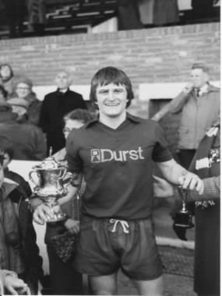
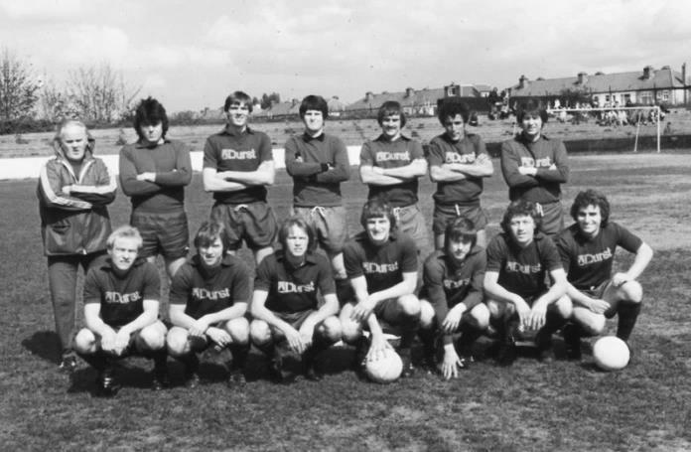
Second Round
Met Police | 13/12 | Kingstonian
Match to be played at Met Police F.C.
Ashford Town (Mx) | 0-1 | Knaphill
Woking | 4-0 | Walton Casuals
Whyteleafe | V | Colliers Wood United
Guildford City | 14/12 | Horley Town
Egham Town | 3-0 | Corinthian Casuals
Godalming Town | 0-1 | Merstham
Molesey | 0-1 | Leatherhead
Raynes Park Vale | 1-1 | Sutton United
Raynes Park Vale won 4-3 on penalties
Sutton Common Rovers | 5-1 | Camberley Town
Dorking Wanderers | 2-1 | South Park
Badshot Lea | 13/12 | Farnham Town
Walton & Hersham | 3-0 | Croydon
Carshalton Athletic | 12/12 | Tooting & Mitcham United
Chertsey Town | 2-1 | Abbey Rangers
Epsom & Ewell | 3-0 | Chipstead

EL Records Premier Challenge Cup
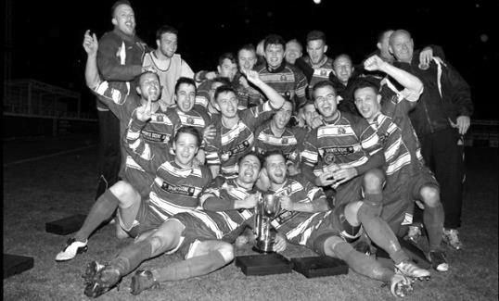
Second Round
Hanworth Villa | 2-4+ | Epsom and Ewell
AFC Hayes | 3-4 | Balham
Epsom Athletic | 1-5 | Windsor
Sutton Common Rovers | 2-1 | Bedfont Sports
Raynes Park Vale | 2-0 | Colliers Wood United
Frimley Green | 1-2 | Banstead Athletic
Westfield | 8-4+ | Redhill
Staines Lammas | 0-1 | Farnham Town
Worcester Park | 8-1 | Cove
Badshot Lea | 0-5 | Guildford City
Chertsey Town | 1-2 | Camberley Town
Cobham | 1-3 | Chessington & Hook United
Hartley Wintney | 4-0 | AC London
Horley Town | 2-2+ 5-4p | Sheerwater
Walton & Hersham | 5-1 | Eversley & California
Ash United | 2-0 | Farleigh Rovers
Third Round
Banstead Athletic | 4-4+ 3-4p | Westfield
Sutton Common Rovers | 19/12 | Walton & Hersham
Farnham Town | 0-4 | Camberley Town
Ash United | 0-2 | Windsor
Raynes Park Vale | 2-1 | Hartley Wintney
Guildford City | 2-1 | Balham
Horley Town | 2-0 | Chessington & Hook United
Worcester Park | 3-6 | Epsom & Ewell
Quarter Finals
Windsor | 24/1 | Horley Town
Guildford City | 25/1 | Raynes Park Vale
Westfield | 17/1 | Camberley Town
Sutton Common Rovers /  Walton & Hersham | V | Epsom & Ewell

CCL Premier Division Club Directory
ABBEY RANGERS Telephone: 01932-422962 - Ground: Addlestone Moor, Addlestone, Surrey KT15 2QH - Colours: Black & White Stripes/Black/Black

A.F.C. HAYES Telephone: 0208-845-0110 - Ground: Farm Park, Kingshill Avenue, Hayes, Middx. UB4 8DD - Colours: Blue and White Stripes/Blue/Blue

BADSHOT LEA Telephone: 01252-320385 - Ground: Ash United FC, Shawfield Stadium, Youngs Drive, Shawfields Road, Ash, Hampshire. GU12 6RE - Colours: Claret/White/Claret

BEDFONT & FELTHAM Telephone: 0208 890 7264 - Ground: The Orchard, Hatton Road, Bedfont, Middx TW14 9QT - Colours: Yellow & Blue/Blue/Blue

BEDFONT SPORTS Telephone: 0208-831-9067 - Ground: Bedfont Sports Club, Hatton Road, Bedfont, Middx TW14 8JA - Colours: Red & Black Hoops/Black/Red & Black Hoops

CAMBERLEY TOWN Telephone: 01276-65392 - Ground: Krooner Park, Wilton Road, Camberley, Surrey. GU15 2QW - Colours: Red & White Stripes/Blue/Red

CB HOUNSLOW UNITED Telephone: 0208 890 7264 - Ground: The Orchard, Hatton Road, Bedfont, Middx TW14 9QT - Colours: Green/Black/Green

CHERTSEY TOWN Telephone: 01932-561774 - Ground: Alwyns Lane, Chertsey, Surrey. KT16 9DW - Colours: Royal Blue & White Stripes/Royal Blue/Royal Blue

COLLIERS WOOD UNITED Telephone: 0208-942 8062 - Ground: Wibbandune Sports Ground, Robin Hood Way, Wimbledon. SW20 0AA - Colours: Blue & Black Stripes/Black/Black
EPSOM & EWELL Telephone: 01737-553250 - Ground: Chipstead FC, High Road, Chipstead, Surrey. CR5 3SF - Colours: Royal Blue & White Hoops/Royal Blue/Royal Blue

FARNHAM TOWN Telephone: 01252-715305 Ground: Memorial Ground, Babbs Mead, West Street, Farnham, Surrey. GU9 7DY Colours: - Claret & Sky Blue /White/ Claret & Sky Blue

GUILDFORD CITY Telephone: 01483-443322 - Ground: The Spectrum, Parkway, Guildford, Surrey. GU1 1UP - Colours: Red & White Stripes/Black/Black

HANWORTH VILLA Telephone: 0208-831-9391 - Ground: Rectory Meadows, Park Road, off Hounslow Road, Hanworth, Middlesex. TW13 6PN - Colours: Red & White Stripes/Black/Black

HARTLEY WINTNEY Telephone: 01252-843586 - Ground: Memorial Playing Fields, Green Lane, Hartley Wintney, Hants RG27 8DL - Colours: Orange & Black/ Orange /Orange

HORLEY TOWN Telephone: 01293-822000 - Ground: The New Defence, Anderson Way, Court Lodge Road, Horley, Surrey. RH6 8SP - Colours: Claret & Sky Blue/Claret/Claret

KNAPHILL Telephone: 01483-475150 - Ground: Brookwood Country Park, Redding Way, Lower Guildford Road, Knaphill, Surrey. GU21 2AY - Colours: Red/Black/Red

NORTH GREENFORD UNITED Telephone: 0208 422 8923 - Ground: Berkeley Fields, Berkeley Avenue, Greenford, Middx UB6 0NX - Colours: Royal Blue & White/Royal Blue/Royal Blue

SUTTON COMMON ROVERS Telephone: 01932-866386 - Ground: Sutton United FC, Gander Green Lane, Sutton, Surrey SM1 2EY - Colours: Yellow/Black/Black

RAYNES PARK VALE Telephone: 020-8540-8843 - Ground: Prince Georges Playing Field, Grand Drive, Raynes Park, London. SW20 9NB - Colours: Blue/Blue/Red

SPELTHORNE SPORTS Telephone: 01932-961055 - Ground: Spelthorne Sports Club, Staines Road, Ashford Common, Ashford, Middx. TW15 1RY - Colours: Light & Dark Blue/Dark Blue/Light Blue

WALTON & HERSHAM Telephone: 01932 245263 - Ground: Stompond Lane, Walton on Thames, Surrey KT12 1HF - Colours: Red/Red/Red

WESTFIELD Telephone: 01483-771106 - Ground: Woking Park, Kingfield Road, Woking, Surrey. GU22 9BA - Colours: Yellow/Black/Black

WINDSOR Telephone: 01753-860656 - Ground: Stag Meadow, St Leonards Road, Windsor, Berks SL4 3DR - Colours: Red/Red/Red

Every Opponent A-Z
Over the years we have played many, many different opponents. Exactly how many is a difficult question, as it all depends on your definition. Are Camberley & Yorktown different to Camberley Town, or are Epsom Town different to Epsom F.C. or Epsom & Ewell F.C.?

In my analysis I have classed both of the above examples as the same team, and will work through them all from A to Z. Some we have played many times, whilst others we have met just once or twice. Enjoy!

Tooting & Mitcham United: Played 35 - W11 D8 L16 - F50 A63 - PPG - 1.17 - Poor

For those who read last week’s programme you may recall that Tooting & Mitcham F.C. were formed by a merger of Tooting Town and Mitcham Wanderers in 1932, adding the United suffix to their name a season later.

This didn’t really change anything as far as we were concerned as they remained a London League opponent. Obviously visits to Streatham Road ceased with the venue being built over soon after this, but we already knew the way to Sandy Lane!

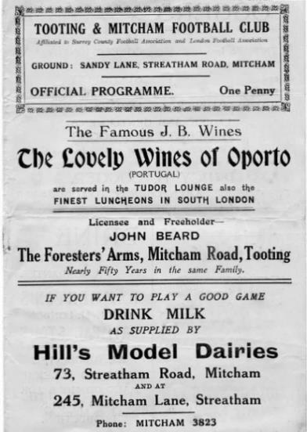
Ironically our first meeting was not for a League match, as the London League determined that we would become Easter opponents for the next five seasons with matches on Good Friday and Easter Monday. Our first meeting came earlier in the season for a Surrey Senior Cup tie on 21st January 1933, losing 2-1 at West Street, although the League matches were won 4-0 over there and 3-0 three days later. The programme pictured is from the away match on Good Friday 14th April 1933.

The following season we met in October for an F.A. Cup tie which we won 1-0 at Sandy Lane. This would prove very significant as our run in this competition would take us to the First Round Proper and a visit to Clapton Orient. The two league matches were drawn.

In 1934/35 we met in October once again, this time for an Amateur Cup tie that we won 3-0 at West Street on the way to our final appearance in the First Round Proper that following January and we won 3-1 in Mitcham with a 1-1 home draw on the Monday. Our record was fairly good against this new team by now, and a 2-1 win and a 2-4 loss at Sandy Lane in 1935/36 were followed by a 2-0 away win and a 0-0 draw at West Street. This would be our last goalless draw for 17 years!

This would also be our last League meeting for nearly fifty years as they were elected to the Athenian League ahead of our club, despite our greater success in the preceding years. It probably came down to ground grading with Sandy Lane accommodating thousands more on stepped terracing around three sides of the ground. We would meet rarely over the next thirty years, although the war time team Epsom Town met them frequently, most importantly at Sandy Lane in the Surrey Senior Cup Final of 1944, where they lost 3-1 in front of 5,000 spectators.

Of those rare meetings, we met in January 1956 for a Surrey Senior Cup tie, although we lost 2-0, and that scoreline was repeated in April 1962 for a Surrey Senior Shield match, although it’s no surprise we failed to score as they had a young Alex Stepney in goal before he joined Millwall and

then Manchester United, picking up a European Cup Winners Medal in 1968 under Matt Busby.

By the late sixties there was quite a gulf between the two sides and we were beaten 5-0 and 5-1 in the Amateur Cup and Surrey Senior Cup in the space of six weeks in 1968/69 with former Epsom player Chris Kelly causing a lot of the damage before he would go on to Leatherhead. We lost narrowly 2-1 at home in 1969/70 also in the Amateur Cup and after we had required four matches to get past Whitehawk in the previous round and our next meeting came on New Year’s Eve 1977 when they knocked us out of the Surrey Senior Cup by three goals to one at Sandy Lane.

The run of straight losses was now at seven but our first win over them since 1937 came in September 1981 when we defeated them 1-0 at west Street in the Isthmian League Cup and just like London Buses another was around the corner as we beat them at the same venue and by the same score on 30th January 1982 in the Surrey Senior Cup. Even the scorer, Steve Hill, was the same in both matches! Of course 1981 was famous for our Surrey Senior Cup win, not against Tooting & Mitcham but the Final was held on their ground when we defeated Woking 2-1.

Both of those wins had been registered against a team that were a division above us. They had been a massive club in the time since we had last beaten them, drawing 2-2 with eventual F.A. Cup winners Nottingham Forest in 1959 and then reaching the Fourth Round of the F.A. Cup in 1976. I have often wondered whether we would have been the club with the success had we been promoted to the Athenian League in 1937. Although a disastrous first half led to an early departure from the League Cup in 1982/83, our next four meetings would be as league equals and although we were relegated in 1986 they produced a win and two draws with five scored and five conceded!

We were harshly dealt with in 1987 when our final F.A. Trophy match for fifteen years was ended 1-0 at Sandy Lane thanks to a penalty conceded by Matt Elliott and by the time of our next meeting in 1995 we were back in Division Three as a Friday night 4-0 defeat ensured that we were the very first team out of the F.A. Cup that season! A couple of Associate Members Trophy matches followed in the late nineties, the first of which, a quarter final, we were conned out of by a horrible linesman’s decision, flagging for offside before then putting the flag back down as he thought we had cleared the danger, only to see the ball put straight back in for what proved to be the winner.

We then had four more meetings in the Isthmian League South Division, again finishing with a win each and two draws. There were some entertaining matches here though, including our first at their new ground of Imperial Fields in March 2003 where we scored twice near the end to win 4-3 and the following season when we let a 3-1 lead slip to a 3-3 draw with all three of their goals scored from outside the penalty area! The most important match came on 3rd January 2004 when goals from Craig Watkins and Ross Shoefield gave us a 2-0 lead but we hadn’t won a game since the August and we folded three times in fifteen minutes and went down by a point later that season!

They have had tough times of their own in recent years with a few internal battles and sit at Step Four these days, although they are pushing for promotion this season. Certainly they have a greater history than those clubs around them, but that doesn’t count for much these days!

Player Sponsorship
Here is the current list for the 2016/17 season showing all of our players and Management that are available for sponsorship.

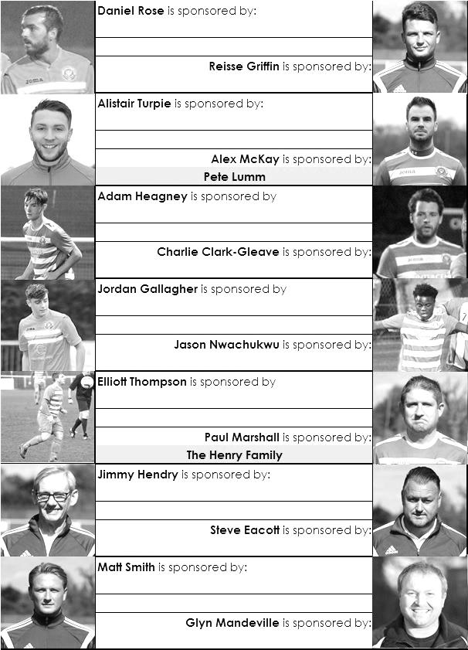

Sponsorship costs just £40 and it is easy to do. Just select a player who has not been previously sponsored and let a Committee Member know that you would like to sponsor them. Beware though. Until we have received the money it is possible for someone to jump in front of you, so don’t delay, sponsor today!
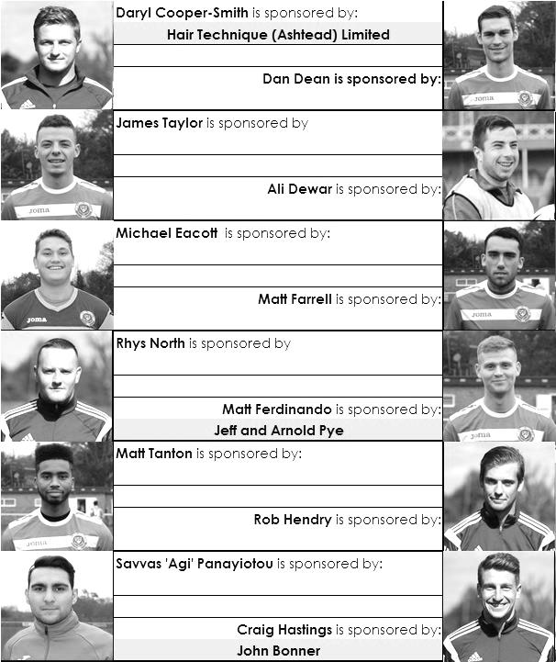

Match and Ball Sponsorships – 2016/17
Opponent | Date | Match Sponsor | Ball Sponsor
Gravesham Borough | 07/08/16 | Club President - Stella Lamont
Gravesham Borough | 07/08/16 | Relocation Committee Member - Mike Lovett
CB Hounslow United | 16/08/16 | EEFC Management Committee
Abbey Rangers | 23/08/16 | Steve & Geoff Dyke
Horley Town (11.30am) | 29/08/16 | In Memory of Chris Henry
Abbey Rangers (LC) | 06/09/16 | Paul Merritt
Camberley Town | 10/09/16 | Building Shop Ltd
Knaphill | 24/09/16 | EEFC Holding Company Director – Pete Lumm
Bridon Ropes (FAV) | 22/10/16 | George and Joseph Saunders
Sutton Common Rovers | 08/11/15 | Alex McKay Senior
Abbey Rangers (FAV) | 13/11/16 | EEFC Holding Company Director – Dave Ellins
Windsor | 15/11/16 | In Memory of Wally Dyke
Bedfont Sports | 19/11/16 | John Bonner
AFC Hayes | 26/11/16 | Jack Jarman
Chipstead (SSC / DWT) | 06/12/16 | Trevor Stotten
Hanworth Villa | 13/12/16 | Roger and Carol Farrell
Chertsey Town | 17/12/16
Raynes Park Vale (11.30am) | 27/12/16
Spelthorne Sports | 07/01/17
Guildford City | 17/01/17
Bedfont & Feltham | 21/01/17 | Programme Editor - Richard Lambert
Badshot Lea | 04/02/17
Westfield | 18/02/17
Walton & Hersham | 04/03/17
Hartley Wintney | 18/03/17
Farnham Town | 25/03/17
Colliers Wood United (1pm) | 14/04/17 | Good Friday match – make a note!
North Greenford United | 22/04/17 | Club President - Stella Lamont
Guildford / Horley (SSC) | tba
For League, League Cup and Surrey Senior Cup Matches:
Match sponsorship - £40.00 Match ball sponsorship - £25.00. Combined £55.00.
For F.A. Cup and F.A. Vase matches:
Match sponsorship - £50.00 Match ball sponsorship - £30.00. Combined £65.00.

Sponsorship includes: (x2 for match, x3 for match and ball)

Admission, programmes, hospitality and advertising and mascot for the day (if required).
If you are interested, just speak to a Committee Member, or drop me an email at: richard.c.lambert@gmail.com

We also thank our Kit Sponsors INTERCEM

Salts Super Six Predictor
The Salts Super Six Predictor is live again for today’s match and the tickets are on sale at today’s game to the left of the gate.

The jackpot has grown steadily and our record figure is now £560. Please note that these matches will be played on Tuesday 13th and Wednesday 14th December.

The competition is easy to play! To win, you simply need to predict the results of six matches correctly from the three options, fill in the form and make sure it is back with our seller before the deadline on the ticket. The latest fixtures are shown below.

If you are a club regular, you just need to place your name on the sheet, although if you aren’t, then we’ll need a contact number from you too. We will announce any winners on the website within three working days, so don’t worry, we won’t miss you!

Please note that if there is more than one winner, the prize pot would be shared between the winners. All you need to do now is have a go, as many times as you like!

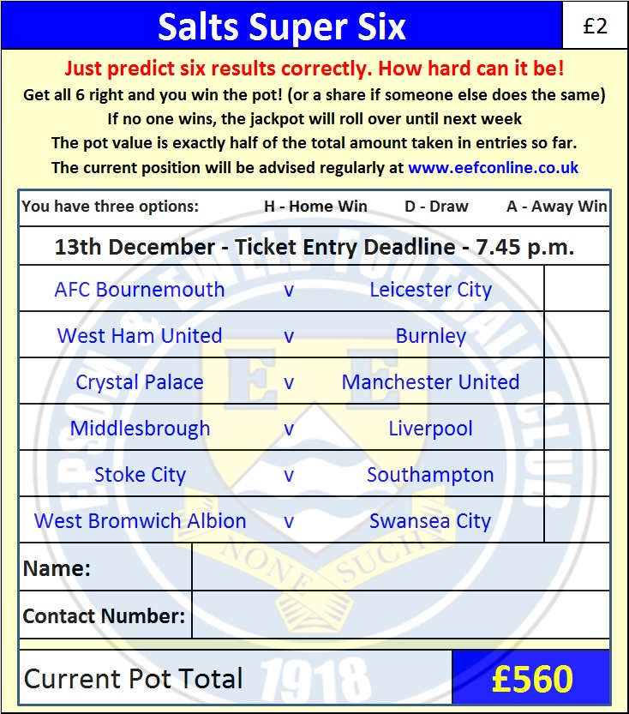

Good luck!

Combined Counties League – Premier Division
Tuesday, 13th December 2016 - Kick-off 7.45 p.m.

Epsom and Ewell  (Royal Blue & White hoops) | V |  | Hanworth Villa  (Red and White)
Squad | NUMBERS |  | Squad
Michael Eacott |  |  | Balvinder Khaira
Adam Heagney |  |  | Steve Loveridge
Matt Tanton |  |  | Dan Millborrow
James Taylor |  |  | Adam Baigent ©
Craig Hastings |  |  | Tom Dilloway
© Dan Dean |  |  | Luke Muldowney
Jordan Gallagher |  |  | Jack Buckle
Matt Farrell |  |  | Levi King
Daryl Cooper-Smith |  |  | Tom Neale
Savvas ‘Agi’ Panayiotou |  |  | Athan Smith-Joseph
Matt Ferdinando |  |  | Cyril Ocansey
Jason Nwachukwu |  |  | Jesse Atiase
Reisse Griffin |  |  | Joe Johnson
Rob Hendry |  |  | Alex McGregor
Alex McKay |  |  | Luke Silavwe
Daniel Rose |  |  | Junior Wright
Alistair Turpie |  |  | Harry Cushen
Charlie Clark-Gleave |  |  | Louis Angol
Matt Smith |  |  | Patrick Motindo
Glyn Mandeville | MANAGER |  | Rufus Brevett
Matt Smith | ASSISTANT |  | Cliff Angol
Steve Eacott / Alex McKay / Jimmy Hendry | COACHES / PHYSIO |  | Bobby Watson / Carl Cleaver
REFEREE: T.Ellsmore
ASSISTANTS: L.Torz-Brown, I.Hempel
Today’s Match and Match Ball are kindly sponsored by
regular supporters Roger and Carol Farrell

OUR NEXT VISITORS TO HIGH ROAD
Chertsey Town
Combined Counties League – Premier Division
Saturday 17th December 2016 – 3.00 p.m.

